Jervin C. Sapid IT3C

ITP 134

**Laboratory 1**

Open up Command Prompt on your computer and type netstat -an. You should now see the listening and established ports; count them, and write the numbers down. Run the shutdown /r /t 0 command to immediately reboot the machine. Log back in, go to Command Prompt, and run netstat -an; what is the difference? If you have lost information or not it could have been used as evidence.

***Note: Attach sample screenshots as evidence.***

**Before**

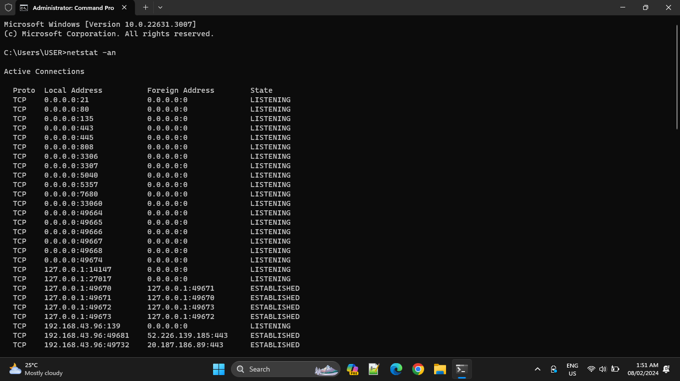

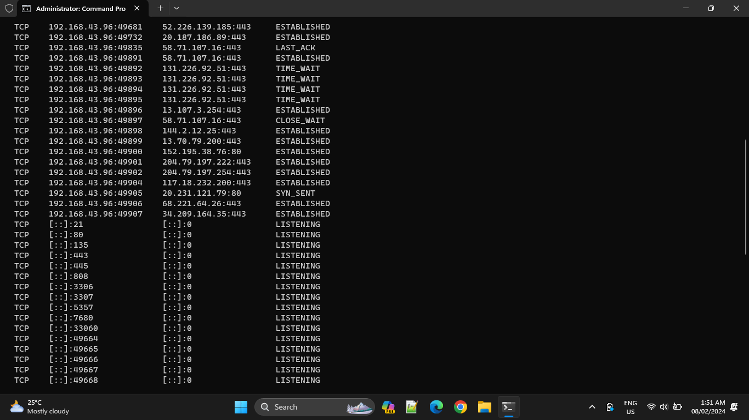

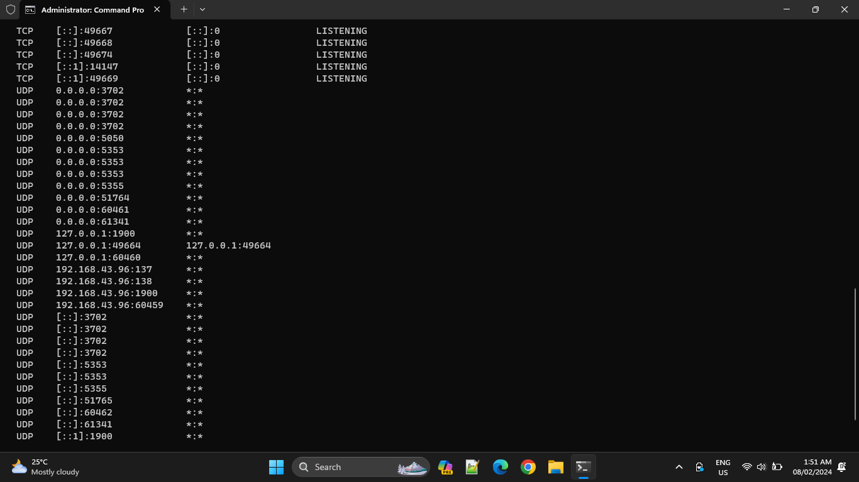



**After Rebooting the machine**

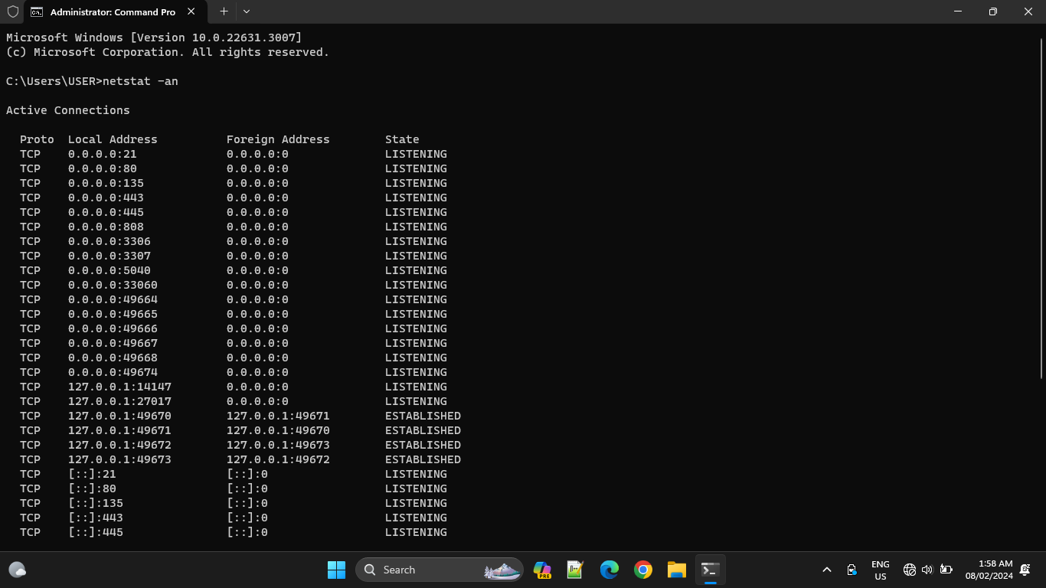

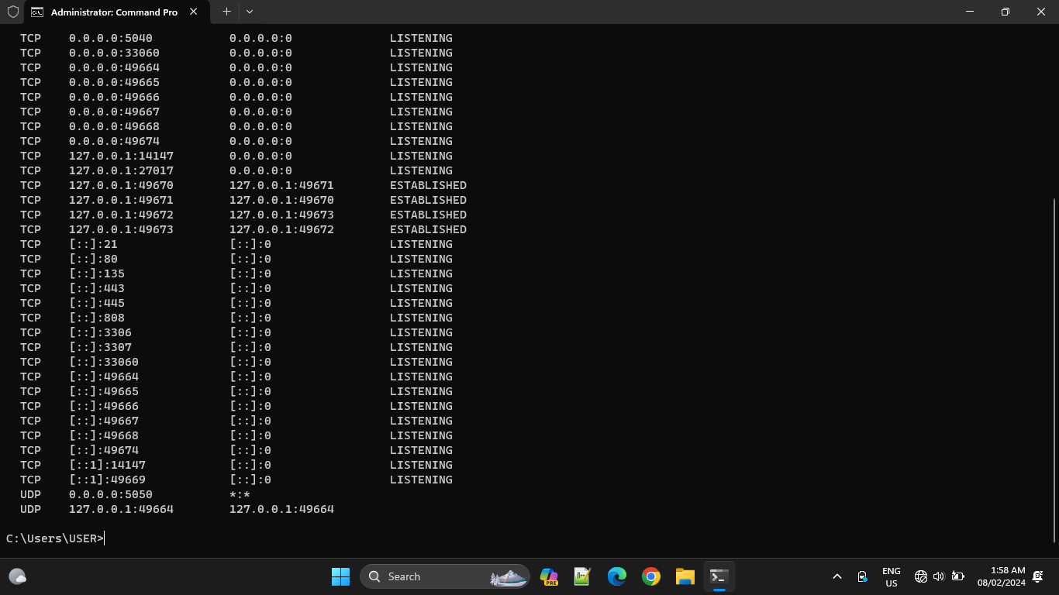

What is the difference?

Based on my observation, the number of TCP and UDP proto before reboot is greater compared to the number of TCP and UDP proto after reboot.

Also, the number of "LISTENING" and "ESTABLISHED" State before is greater compared to after reboot.

Before Reboot

LISTENING : 40

ESTABLISHED : 16

After Reboot

LISTENING : 35

ESTABLISHED : 4